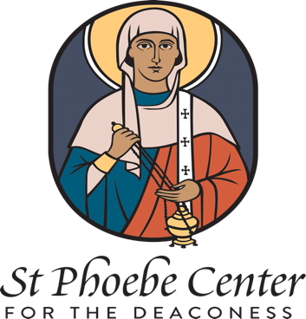

St. Phoebe Center for the Deaconess
African Women’s Grant Application

All around the continent of Africa women participate in the life of the Orthodox Church. In roles such as catechist, church treasurer, theologian, and chanter, women from Kenya to Cameroon to Zimbabwe work to build up the Body of Christ.

Honoring the fact that women are richly engaged in African Orthodoxy, the St. Phoebe Center for the Deaconess wishes to support their efforts to acquire education and skills in order to better serve God. To this end, the St. Phoebe Center has established an African Orthodox Women’s Grant. African Orthodox women are invited to apply for funding to better equip themselves to contribute to the life of the Church. Funds may be requested for conference expenses, tuition for seminary, or other projects relating to women in the African Orthodox Church.

Please fill out the following application and send it to the St. Phoebe Center Chair Carrie Frederick Frost: stphoebecenter@gmail.com. Most grant awards will be less than $1000.
Additional information including letters of recommendation or itemized plans may be requested.

Due Dates and Notification Dates
Applications may be submitted throughout the year, but will be reviewed quarterly. Due dates for applications are:
March 1 (notification by March 31)
June 1 (notification by June 30)
September 1 (notification by September 30)
December 1 (notification by December 31)

Date
First name
Last name
Mailing address
Phone
Email
Orthodox Church and Metropolis
Orthodox Parish and Location
Describe proposed plan/project in less than 300 words.
Explain why this project is important for women in the African Orthodox Church.
Projected expenses, with a total. (Most grants will be for less than $1000)

